Composite PS Promotion and Deployment Tool

Data Source Module User Guide
Composite Professional Services
March 2015
Composite Data Virtualization
TABLE OF CONTENTS
INTRODUCTION 4
License 4
Purpose 4
Audience 4
How To Create a Data Source XML Entry 6
Update, Enable or Re-introspect a Data Source 6
Introspect a Data Source 10
DataSource Module definition 14
Method Definitions and Signatures 14
1. updateDataSources 14
2. enableDataSources 14
3. reIntrospectDataSources 14
4. introspectDataSources 15
5. generateDataSourcesXML 15
6. generateDataSourceAttributeDefs 15
7. generateDataSourceAttributeDefsByDataSourceType 16
8. generateDataSourceTypes 17
9. generateDataSourcesResourceListXML 17
DataSource module xml configuration 19
Description of the Module XML 19
Relational Attributes of Interest 21
Generic Attributes of Interest 22
Custom and System Properties 23
Attribute Value Restrictions 23
Introspect Attributes of Interest 24
how to execute 27
Script Execution 27
Ant Execution 29
Module ID Usage 30
examples 32
Scenario 1 – Generate DataSource Module XML 32
Scenario 2 – Update Data Source 32
Scenario 3 – Introspect Data Source 33
Exceptions and messages 35
Introspection Report 36
conclusion 39
Concluding Remarks 39
How you can help! 39

Document Control

Version History
Version | Date | Author | Description
1.0 | 8/5/2011 | Mike Tinius | Initial version for DataSource Module User Guide
1.1 | 5/8/2013 | Mike Tinius | Added support for generic attributes of type ValueArray, ValueList and ValueMap
1.2 | 8/19/2013 | Mike Tinius | Added new methods and modified the XML Schema. New methods: introspectDataSources, generateDataSourceAttributeDefs, generateDataSourceAttributeDefsByDataSourceType, generateDataSourceTypes, and generateDataSourcesResourceListXML.
3.0 | 8/21/2013 | Mike Tinius | Updated docs to Cisco format.
3.1 | 2/18/2014 | Mike Tinius | Prepare docs for open source.
3.2 | 3/24/2014 | Mike Tinius | Changed references of XML namespace to www.dvbu.cisco.com
3.3 | 11/17/2014 | Mike Tinius | Updated license.
3.4 | 03/04/05 | Mike Tinius | Updated table of contents to include methods.

Related Documents
Document | File Name | Author
Composite PS Promotion and Deployment Tool User's Guide v1.0 | Composite PS Promotion and Deployment Tool User's Guide v1.0.pdf | Mike Tinius

Composite Products Referenced
Composite Product Name | Version
Composite Information Server | 5.1, 5.2, 6.0, 6.1, 6.2

INTRODUCTION

License
(c) 2014 Cisco and/or its affiliates. All rights reserved.
This software is released under the Eclipse Public License. The details can be found in the file LICENSE. Any dependent libraries supplied by third parties are provided under their own open source licenses as described in their own LICENSE files, generally named .LICENSE.txt. The libraries supplied by Cisco as part of the Composite Information Server/Cisco Data Virtualization Server, particularly csadmin-XXXX.jar, csarchive-XXXX.jar, csbase-XXXX.jar, csclient-XXXX.jar, cscommon-XXXX.jar, csext-XXXX.jar, csjdbc-XXXX.jar, csserverutil-XXXX.jar, csserver-XXXX.jar, cswebapi-XXXX.jar, and customproc-XXXX.jar (where -XXXX is an optional version number) are provided as a convenience, but are covered under the licensing for the Composite Information Server/Cisco Data Virtualization Server. They cannot be used in any way except through a valid license for that product.
This software is released AS-IS!. Support for this software is not covered by standard maintenance agreements with Cisco. Any support for this software by Cisco would be covered by paid consulting agreements, and would be billable work.

Purpose
The purpose of the DataSource Module User Guide is to demonstrate how to effectively use the DataSource Module and execute actions. Once CIS resources are imported into a target CIS server during the deployment process, it is typically necessary to update the data source configuration. Usually, the user and password need updating. In some cases, the URL might have to change due to different ports. Whatever the reason, the DataSource Module provides the mechanism to automate the configuration of data source attributes. Using the “updateDataSources” method and pointing at an identifier within the DataSourceModule.xml configuration file, the user of this tool will be able to execute a command-line or Ant script that will automatically connect to the target CIS server and perform the update. Additionally, the user can automate enabling and re-introspecting a data source on the target CIS server. Finally, to make it easier on the developer or administrator who is configuring the deployment plan, they would use the “generateDataSourcesXML” to reach into the source server where the artifacts are being deployed from and generate the DataSourceModule XML. Then, all they need to do is tweak a few configuration lines based on what the values are for the target CIS server. The DataSourceModule XML becomes part of the deployment plan that they will use during the automated deployment process.

Audience
This document is intended to provide guidance for the following users:
- Architects
- Developers
- Administrators.
- Operations personnel.

How To Create a Data Source XML Entry
The following section describes the workflow for setting up a Data Source Module XML entry to update, enable, re-introspect or introspect a data source. Essentially, there is a process by which a developer goes about creating an entry in the DataSourceModule.xml. One approach is to create entries from scratch. Even if you decided to start from scratch, it is easier to copy an existing entry from the samples. Another approach is to generate a template and then modify it. This section is more about the process of creating entries. Full descriptions for the XML structure and methods will be provided in later sections of this document.

Update, Enable or Re-introspect a Data Source
These actions are grouped together because they all use the same XML structure. Suffice it to say that the XML provides a choice of children. For these actions, the choice may be the “Relational Data Source XML” structure or the “Generic Data Source XML” structure.
- Generate a Template – this approach is used when the user wants to point at the development environment and generate a template of the existing data sources. This is the recommended approach as there is less editing involved and less chances for mistakes.
  - Configure a generate data source deployment plan
The following example shows how to “generateDataSourcesXML” for a given target “$SERVERID”, a starting path of “/shared/test00” and output the XML into the file “getDataSourceModule.xml” in the directory "$MODULE_HOME/generated”.
Entry in the deployment plan “myds.dp”
PASS FALSE ExecuteAction generateDataSourcesXML $SERVERID /shared/test00 "$MODULE_HOME/generated/getDataSourceModule.xml" "$MODULE_HOME/servers.xml"
  - Execute the generate data source deployment plan
The following shows how to execute the file:
ExecutePDTool -exec ../resources/plans/myds.dp
  - Rename the file or copy the generated data source module XML entries
Rename getDataSourceModule.xml to DataSourceModule.xml or whatever name fits your environment. Move it from the generated directory to the main /modules directory. This is done so that the next time you generate the data sources, you won’t overwrite the modified file.
  - Modify the entries for the target deployment environment
Modify Connection Details
Typically the developer will modify the connection information such as user and password. The other attributes generally do not change between environments.
Modify Attributes
If attributes are different between environments then make adjustments as needed. Review the “Helpful Tips For Adding Attributes” section.
- Create from Scratch – this approach is used when the user wants to create the data source module XML by hand. There is more editing involved in this approach.
  - Create a Data Source Module XML template (copy the entries from a sample)
Copy the DataSourceModule.xml sample and give it a name appropriate for you environment.
  - Modify the entries for the target deployment environment
Modify Connection Details and Attributes
The developer will need to modify the connection information for all of the attributes. Review the “Helpful Tips For Adding Attributes” section.
- Helpful Tips For Adding Attributes – This provides a helpful tip for finding the valid list of attributes for a particular type of data source:
  - Find the Display Name for an Attribute – use Composite Studio
The display name can be found to the left of the edit box on the basic and advanced tabs of the data source. The display name will be used to search for the attribute definition “displayName” which then allows the developer to locate the attribute “name” and “type” that they will use to modify the DataSourceModule.xml attribute.
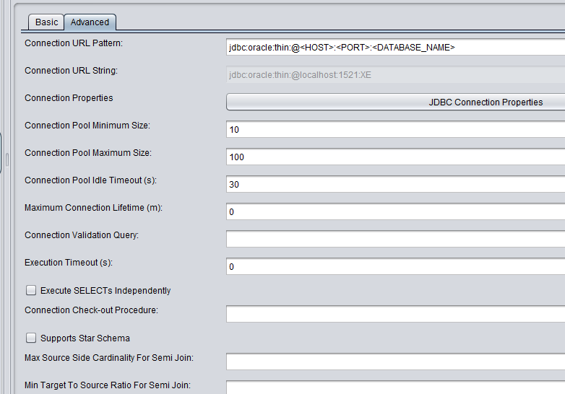
The red box shows the display name for a given attribute. Use it to locate the attribute definition “displayName”. Example:
- Connection Pool Maximum Size
- Connection Pool Idle Timeout (s)
  - Find an attribute for a data source – generateDataSourceAttributeDefs.xml
Method: generateDataSourceAttributeDefs – This method takes in a starting path and will locate all of the data sources within that path and export the list of attributes for each data source.
Method: generateDataSourceAttributeDefsByDataSourceType – This method takes in a specific data source type and exports the list of attributes for that type of data source. The data source type can be acquired by executing the method “generateDataSourceTypes” or “generateDataSourcesXML” for a targeted list.
- generateDataSourceTypes – Generate the entire list of data source types available in the Composite Server.
- generateDataSourcesXML – Generate a list of all data sources and their associated data source types.
The red box shows what to look for. Search for your resource path to find the data source type.
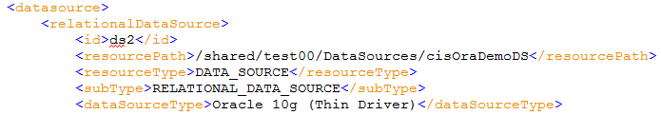
These methods are useful when the developer needs to add an attribute to their Data Source Module XML but does not know what the attribute name is. Using Composite Studio, locate the display name in studio, find the correct data source entry and then locate the display name for that data source entry. A data source entry is identified by the “resourcePath”. Create a deployment plan to generate data source attribute definitions to a file.
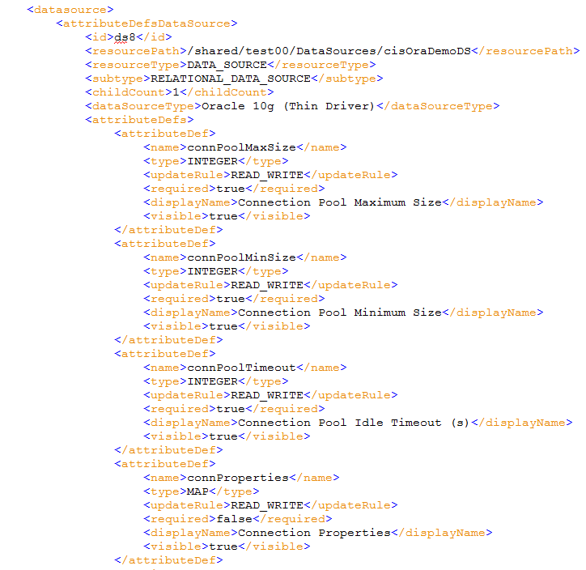
The red box shows what to look for. The blue box shows what to put in the DataSourceModule.xml.
  - Generate a Data Source Module template – generateDataSourcesXML.xml
generateDataSourcesXML – This method takes in a starting path and will locate all of the data sources within that path and generate a Data Sources Module template. This template can then be renamed or copied to create the master “DataSourceModule.xml”. Create a deployment plan to execute this method. Steps 3.2 and 3.3 can be executed in one deployment plan.
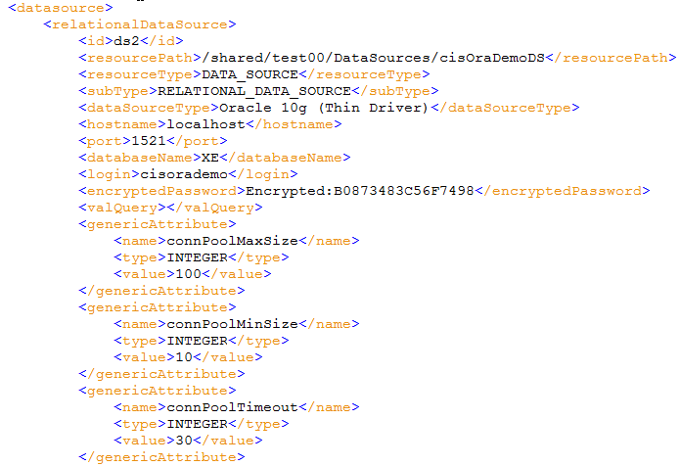
The blue box shows what was edited from the output of the file generateDataSourceAttributeDefs.xml

Introspect a Data Source
The introspect action uses the “Introspect Data Sources” choice of children XML structure. The use case for this is to add, update or remove data source children. For example, if the data source schema or catalog name in development is different than the one in test, UAT or production, then this deployment method would be used.
- Create from Scratch – this approach is used when the user wants to create the data source module XML by hand.
  - Create a Data Source Module XML template (copy the entries from a sample)
The sample file is located at /resources/modules/DataSourceModule.xml. Copy this file to a master file for the target environment.
If the master file already exists, then copy a sample entry from the DataSourceModule.xml as shown below.
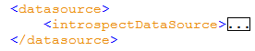
  - Modify the entries for the target deployment environment
Open the new file and edit it. Delete entries that are not applicable. Add new entries as needed. Add attributes as necessary. Add plan entries as necessary. The following screen shot shows an example of what an introspect XML looks like:
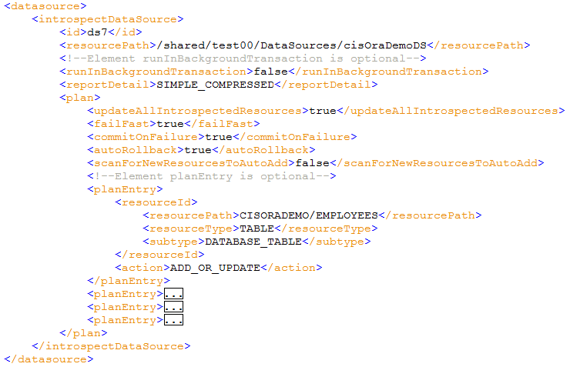
  - Guidance
- Relative Paths – The planEntry/resourceId/resourcePath is a relative path from the data source “resourcePath”. Any level of relative path can be specified. For example, for a relational database with both a catalog, schema and tables, any of those three levels may be specified. The higher up in the path the more time it will take to introspect and thus more objects will be brought into CIS. The lower in the relative path you go, the more targeted you get and less time will be needed for introspection.
- Actions – The actions include “REMOVE”, “ADD_OR_UPDATE”, or “ADD_OR_UPDATE_RECURSIVELY”.
  - In the above example, CISORADEMO is the schema name and EMPLOYEES is a database table. Here are some examples of using the different actions:
    - To remove a specific table set the action

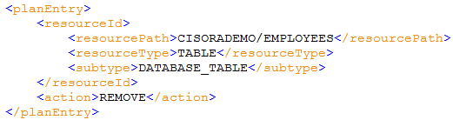
    - To add or update a specific database table object for a schema container set plan entry as follows:
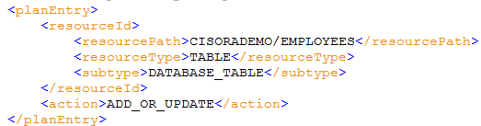
    - To add or update all objects for a schema container set plan entry as follows:
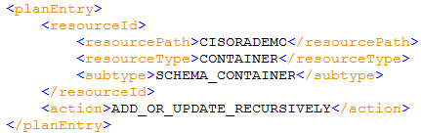
- Locating resourceType and subtype
  - Each plan entry contains a “resourceId” grouping that specifies the relative path to the resource “resourcePath”, the type of resource “resourceType” and the sub type “subtype”.
  - The list shown below is not a complete list but shows the most popular type/subtype combinations.
Resource Type | Sub Type | Definition
DATA_SOURCE | RELATIONAL_DATA_SOURCE | A relational database source
DATA_SOURCE | XML_FILE_DATA_SOURCE | A comma separate file data source
DATA_SOURCE | WSDL_DATA_SOURCE | An XML file data source
DATA_SOURCE | XML_HTTP_DATA_SOURCE | A Composite web service data source
DATA_SOURCE | NONE | A custom java procedure data source
CONTAINER | FOLDER_CONTAINER | A Composite folder
CONTAINER | DIRECTORY_CONTAINER | A Composite directory
CONTAINER | CATALOG_CONTAINER | A Composite catalog folder under a data source
CONTAINER | SCHEMA_CONTAINER | A Composite schema container under a data source
CONTAINER | SERVICE_CONTAINER | A web service container for the service
CONTAINER | OPERATIONS_CONTAINER | A web service container for the operations
CONTAINER | PORT_CONTAINER | A Composite web service container for port
CONTAINER | CONNECTOR_CONTAINER | A Composite container for connectors
TABLE | DATABASE_TABLE | A Composite database table
PROCEDURE | DATABASE_PROCEDURE | A database stored procedure
TREE | XML_FILE_TREE | The XML tree associated with a file-XML data source

  - Determine the exact resource type and subtype for a resource.
generateDataSourcesResourceListXML – This method takes in a starting path and will locate all of the data sources within that path and generate a data source resource list including children. The image below shows an example of a relational data source. As you can see, the relevant information regarding path, resource type and sub type are present. This provides enough information to create a plan entry.
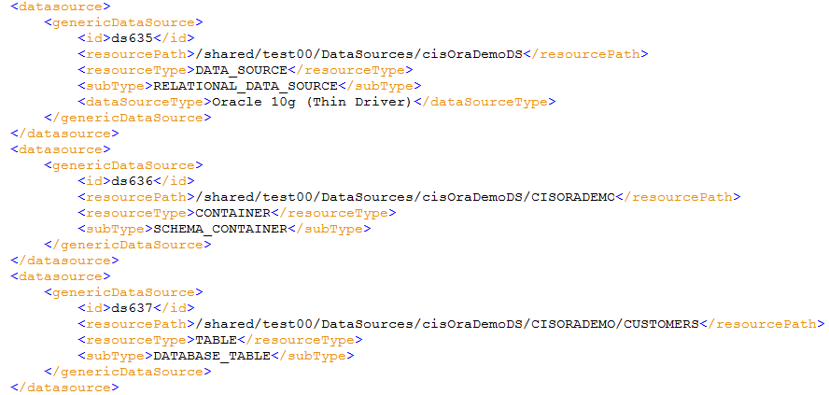

DataSource Module definition

Method Definitions and Signatures

updateDataSources
Update Data Source method updates data source configurations based on the values identified by the data source id in the DataSourceXML and the target server.
@param serverId target server id from servers config xml
@param dataSourceIds list of data sources Ids(comma separated data source Ids)
@param pathToDataSourceXML path to the data source xml
@param pathToServersXML path to the server values xml
@throws CompositeException
public void updateDataSources(String serverId, String dataSourceIds, String pathToDataSourceXML, String pathToServersXML) throws CompositeException;

enableDataSources
Enable a data source for access.
@param serverId target server id from servers config xml
@param dataSourceIds list of data sources Ids(comma separated data source Ids)
@param pathToDataSourceXML path to the data source xml
@param pathToServersXML path to the server values xml
@throws CompositeException
public void enableDataSources(String serverId, String dataSourceIds, String pathToDataSourceXML, String pathToServersXML) throws CompositeException;

reIntrospectDataSources
Re-introspect a data source.
@param serverId target server id from servers config xml
@param dataSourceIds list of comma separate data sources Ids
@param pathToDataSourceXML path to the data source xml
@param pathToServersXML path to the server values xml
@throws CompositeException
public void reIntrospectDataSources(String serverId, String dataSourceIds, String pathToDataSourceXML, String pathToServersXML) throws CompositeException;

introspectDataSources
Introspect a data source to add, update or remove children resources. This method is useful when the catalog or schema name in your target deployment environment is different than what was used in the development environment. This allows the deployment administrator to add resource data base tables to a different schema name at deployment time.
@param serverId target server id from servers config xml
@param dataSourceIds list of comma separate data sources Ids
@param pathToDataSourceXML path to the data source xml
@param pathToServersXML path to the server values xml
@throws CompositeException
public void introspectDataSources(String serverId, String dataSourceIds, String pathToDataSourceXML, String pathToServersXML) throws CompositeException;

generateDataSourcesXML
Generate the DataSourceXML based on the starting path passed in and the target server information. Generate the XML to the file location passed in.
@param serverId target server id from servers config xml
@param startPath starting path of the resource e.g /shared
@param pathToDataSourceXML path including name to the data source xml which needs to be created
@param pathToServersXML path to the server values xml
@throws CompositeException
public void generateDataSourcesXML(String serverId, String startPath, String pathToDataSourceXML, String pathToServersXML) throws CompositeException;

generateDataSourceAttributeDefs
Generate Data Source Attribute Definitions for the passed in starting path and the target server Id. The method allows the invoker generate a file of data source attribute definitions. This method will be useful when the user wants to determine what valid attributes are available for a given data source. This method will search for all data sources within the given “startPath” and export the attributes for those data sources found.
The content of this method is useful when creating the attributes for the DataSourceModule.xml. For example, let’s say that you are in Composite Studio and want to determine how to set the “Connection Pool Maximum Size”. That string is known as the “displayName” in the attribute definition below. The first thing that you would do is search for your specific data source path. Within that node of the XML, you would then search for the “displayName”. Once you find that the “name” attribute defines the attribute name to be set in the DataSourceModule.xml. The “type” defines the type to be set. In order to create a new attribute in the DataSourceModule.xml, it must have an update rule of READ_WRITE. An example attribute definition is shown below:
<attributeDef>
<name>connPoolMaxSize</name>
<type>INTEGER</type>
<updateRule>READ_WRITE</updateRule>
<required>true</required>
<displayName>Connection Pool Maximum Size</displayName>
<visible>true</visible>
</attributeDef>

@param serverId target server id from servers config xml
@param startPath starting path of the resource e.g /shared
@param pathToDataSourceAttrDefs path to the data attribute definitions xml
@param pathToServersXML path to the server values xml
@throws CompositeException
public void generateDataSourceAttributeDefs(String serverId, String startPath, String pathToDataSourceAttrDefs, String pathToServersXML) throws CompositeException;

generateDataSourceAttributeDefsByDataSourceType
Generate Data Source Attribute Definitions for the passed in data source type and the target server Id. The method allows the invoker generate a file of data source attribute definitions. This method will be useful when the user wants to determine what valid attributes are available for a specific data source. This method will only return the attributes for the single data source type passed in.
The content of this method is useful when creating the attributes for the DataSourceModule.xml. For example, let’s say that you are in Composite Studio and want to determine how to set the “Connection Pool Maximum Size”. That string is known as the “displayName” in the attribute definition below. The first thing that you would do is search for your specific data source path. Within that node of the XML, you would then search for the “displayName”. Once you find that the “name” attribute defines the attribute name to be set in the DataSourceModule.xml. The “type” defines the type to be set. In order to create a new attribute in the DataSourceModule.xml, it must have an update rule of READ_WRITE. An example attribute definition is shown below:
<attributeDef>
<name>connPoolMaxSize</name>
<type>INTEGER</type>
<updateRule>READ_WRITE</updateRule>
<required>true</required>
<displayName>Connection Pool Maximum Size</displayName>
<visible>true</visible>
</attributeDef>

@param serverId target server id from servers config xml
@param dataSourceType a valid data source type which can be found in "getDataSourceTypes" output
@param pathToDataSourceAttrDefs path to the data attribute definitions xml
@param pathToServersXML path to the server values xml
@throws CompositeException
public void generateDataSourceAttributeDefsByDataSourceType(String serverId, String dataSourceType, String pathToDataSourceAttrDefs, String pathToServersXML) throws CompositeException;

generateDataSourceTypes
Generate Data Source Types for the Composite Server. The method allows the invoker generate a file of data source types for the Composite Server. The value of “dataSourceType” element can be used as input to the method “generateDataSourceAttributeDefsByDataSourceType”. An example data source type XML is shown below:
<dataSourceType>
<name>Oracle 11g (Thin Driver)</name>
<type>Oracle</type>
<attribute>
<name>driverClass</name>
<type>STRING</type>
<value>oracle.jdbc.OracleDriver</value>
</attribute>
<attribute>
<name>urlPattern</name>
<type>STRING</type>
<value>jdbc:oracle:thin:@&lt;HOST&gt;:&lt;PORT&gt;:&lt;DATABASE_NAME&gt;</value>
</attribute>
</dataSourceType>

@param serverId target server id from servers config xml
@param pathToDataSourceTypesXML path to the data source types xml
@param pathToServersXML path to the server values xml
@throws CompositeException
public void generateDataSourceTypes(String serverId, String pathToDataSourceTypesXML, String pathToServersXML) throws CompositeException;

generateDataSourcesResourceListXML
Generate Data Sources Resource List for a starting path and target server Id will export all of the Data Sources found and their children. This will be useful to know the type and subtype for a particular data source child when constructing the "plan" entries for the "introspectDataSources" method. An example SQL Server relational database resource list XML is shown below. The developer can use path, type and subtype to determine how best to construct the plan entries.
<genericDataSource>
<id>ds1</id>
<resourcePath>/shared/test00/DataSources/MyDS</resourcePath>
<resourceType>DATA_SOURCE</resourceType>
<subType>RELATIONAL_DATA_SOURCE</subType>
<dataSourceType>Microsoft SQL Server 2008</dataSourceType>
</genericDataSource>
</datasource>
<datasource>
<genericDataSource>
<id>ds2</id>
<resourcePath>/shared/test00/DataSources/MyDS/MyCatalog</resourcePath>
<resourceType>CONTAINER</resourceType>
<subType>CATALOG_CONTAINER</subType>
</genericDataSource>
</datasource>
<datasource>
<genericDataSource>
<id>ds3</id>
<resourcePath>/shared/test00/DataSources/MyDS/MyCatalog/dbo</resourcePath>
<resourceType>CONTAINER</resourceType>
<subType>SCHEMA_CONTAINER</subType>
</genericDataSource>
</datasource>
<datasource>
<genericDataSource>
<id>ds4</id>
<resourcePath>/shared/test00/DataSources/MyDS/MyCatalog/dbo /Customer</resourcePath>
<resourceType>TABLE</resourceType>
<subType>DATABASE_TABLE</subType>
</genericDataSource>
</datasource>

@param serverId target server id from servers config xml
@param startPath starting path of the resource e.g /shared
@param pathToDataSourceResourceListXML path including name to the data source resource list xml which needs to be created
@param pathToServersXML path to the server values xml
@throws CompositeException
void generateDataSourcesResourceListXML(String serverId, String startPath, String pathToDataSourceResourceListXML, String pathToServersXML) throws CompositeException;
General Notes:
The arguments pathToDataSourceXML and pathToServersXML will be located in PDTool/resources/modules. The value passed into the methods will be the fully qualified path. The paths get resolved when executing the property file and evaluating the $MODULE_HOME variable.
.
DataSource module xml configuration
A full description of the PDToolModule XML Schema can be found by reviewing /docs/PDToolModules.xsd.html.

Description of the Module XML
The DataSourceModule XML provides a structure “DatasourceModule”.
The global entry point node is called “DataSourceModule” and contains one or more “datasource” nodes. The XML is constructed as a “Choice of Children”
<!—Choice of Children:

<xs:complexType name="DataSourceChoiceType">
<xs:annotation>
<xs:documentation xml:lang="en">
Data Source Choice Type: This selection provides a choice between the relational source, generic source, introspection, attribute definition and data source types.
</xs:documentation>
</xs:annotation>
<xs:choice>
<xs:element name="relationalDataSource" maxOccurs="1" minOccurs="0" type="ns:RelationalDataSourceType"/>
<xs:element name="genericDataSource" minOccurs="0" type="ns:GenericDataSourceType" maxOccurs="1"/>
<xs:element name="introspectDataSource" minOccurs="0" type="ns:IntrospectDataSourceType" maxOccurs="1"/>
<xs:element name="attributeDefsDataSource" minOccurs="0" type="ns:AttributeDefsDataSourceType" maxOccurs="1"/>
<xs:element name="dataSourceTypesDataSource" minOccurs="0" type="ns:DataSourceTypesType" maxOccurs="1"/>
</xs:choice>
</xs:complexType>
The various operations are shown below with the choice of children indicated
- enable – enable a data source
  - use Choice of relationalDataSource or genericDataSource
- reintrospect – update existing data source resources
  - use Choice of relationalDataSource or genericDataSource
- introspect – add, update, remove resources from a data source
  - use Choice of introspectDataSource
- updateDataSource – Modify attributes for a data source
  - use Choice of relationalDataSource or genericDataSource
- generateDataSourceXML – generate the DataSourceModule.xml template from an existing data source.
  - use Choice of relationalDataSource or genericDataSource
- generateDataSourceAttributeDefs – generate data source attribute definitions
  - use Choice of attributeDefsDataSource
- generateDataSourceAttributeDefsByDataSourceType – generate data source attribute definitions
  - use Choice of attributeDefsDataSource
- generateDataSourceTypes – generate data source types
  - use Choice of dataSourceTypesDataSource
The following chart shows an example of a “relationalDataSource” structure:
<p1:DatasourceModule xmlns:p1="http://www.dvbu.cisco.com/ps/deploytool/modules">

<!—Example of a Relational specific attributes only for configuration:
<datasource>
<relationalDataSource>
<id>ds1</id>
<resourcePath>/shared/examples/ds_orders</resourcePath>
<hostname>localhost</hostname>
<port>9408</port>
<databaseName>orders</databaseName>
<login>tutorial</login>
<encryptedPassword>tutorial</encryptedPassword>
<valQuery>select 1 from dual</valQuery>
</relationalDataSource>
</datasource>

<!—Example of a File data source using generic attributes for configuration:
<datasource>
<genericDataSource>

<id>ds2</id>
<resourcePath>/shared/test1/ServerAttributeDefinitions</resourcePath>

<genericAttribute>
<name>filters</name>
<type>STRING</type>
<value>*.xml</value>
</genericAttribute>

<genericAttribute>
<name>root</name>
<type>STRING</type>
<value>$PROJECT_HOME\resources\modules</value>
</genericAttribute>
</genericDataSource>
</datasource>

<!—Example of a Relational data source using specific relation attributes and generic attributes for configuration:
<datasource>
<relationalDataSource>
<id>ds3</id>
<resourcePath>/shared/test00/DataSources/ds_orders</resourcePath>
<hostname>localhost</hostname>
<port>9408</port>
<databaseName>orders</databaseName>
<login>tutorial</login>
<encryptedPassword>Encrypted:A49A5A0FAFF13F4A</encryptedPassword>
<valQuery></valQuery>

<genericAttribute>
<name>autoAddChildren</name>
<type>BOOLEAN</type>
<value>true</value>
</genericAttribute>
<genericAttribute>
<name>commitOnFetchDone</name>
<type>BOOLEAN</type>
<value>false</value>
</genericAttribute>
<genericAttribute>
<name>connPoolMaxSize</name>
<type>INTEGER</type>
<value>100</value>
</genericAttribute>
<genericAttribute>
<name>connPoolMinSize</name>
<type>INTEGER</type>
<value>10</value>
</genericAttribute>
<genericAttribute>
<name>connPoolTimeout</name>
<type>INTEGER</type>
<value>30</value>
</genericAttribute>
<genericAttribute>
<name>execTimeout</name>
<type>INTEGER</type>
<value>0</value>
</genericAttribute>
<genericAttribute>
<name>isPassThrough</name>
<type>STRING</type>
<value>Disabled</value>
</genericAttribute>
<genericAttribute>
<name>persistPassword</name>
<type>BOOLEAN</type>
<value>true</value>
</genericAttribute>
<genericAttribute>
<name>streamingResults</name>
<type>BOOLEAN</type>
<value>true</value>
</genericAttribute>
<genericAttribute>
<name>txnIsolationLevel</name>
<type>STRING</type>
<value>Read Committed</value>
</genericAttribute>
<genericAttribute>
<name>urlPatternStr</name>
<type>STRING</type>
<value>jdbc:mysql://&lt;HOST&gt;:&lt;PORT&gt;/&lt;DATABASE_NAME&gt;</value>
</genericAttribute>
</relationalDataSource>
</datasource>
</p1:DatasourceModule>

Relational Attributes of Interest
id – The unique identifier within the DataSourceModule.xml file that is used to identify a data source resource configuration.
resourcePath – the CIS path to the data source resource.
hostname – the qualified data base hostname.
port – the database port.
databaseName – The database name or SID for oracle.
login – the database users login.
encryptedPassword – the password for the specified data source. Use the following syntax to encrypt the DataSourceModule.xml file:
ExecutePDTool.[bat|.sh] -encrypt ../resources/modules/DataSourceModule.xml
valQuery – a SQL validation query in the specific syntax of the underlying data source.
genericAttribute – zero or more iterations of the Generic Attributes type defined in the section below.

Generic Attributes of Interest
name – The name of the attribute. The method generateDataSourcesXML will generate a file that will contain all of the writable generic attributes. This allows the user to simply modify values rather than having to know all of the names.
type – The type of the attribute as defined by the AttributeTypeSimpleType described in the attribute value restrictions section below.
Value is one of value or valueArray or valueList or valueMap.
value – (optional) The value for the attribute name.
<genericAttribute>
<name>LowerBoundForDataShip</name>
<type>LONG</type>
<value>100</value>
</genericAttribute>
valueArray – (optional) The value array for the attribute name.
<genericAttribute>
<name>valueArrayName</name>
<type>STRING_ARRAY</type>
<valueArray>
<!--Element item is optional, maxOccurs=unbounded-->
<item>value1</item>
<item>value2</item>
<item>value3</item>
</valueArray>
</genericAttribute>
valueList – (optional) The value list for the attribute name.
<genericAttribute>
<name>valueListName</name>
<type>LIST</type>
<valueList>
<!--Element item is optional, maxOccurs=unbounded-->
<item>
<!--Element type is optional-->
<type>STRING</type>
<!--Element value is optional-->
<value>string</value>
</item>
<item>
<!--Element type is optional-->
<type>STRING</type>
<!--Element value is optional-->
<value>string</value>
</item>
</valueList>
</genericAttribute>
valueMap – (optional) The value map for the attribute name.
<genericAttribute>
<name>DBLinkList</name>
<type>MAP</type>
<valueMap>
<entry>
<key>
<type>STRING</type>
<value>COMPOSITE_$ENV</value>
</key>
<value>
<type>STRING</type>
<value>/shared/Common/Org/Physical/Metadata/Warehouse/DB1</value>
</value>
</entry>
</valueMap>
</genericAttribute>

Custom and System Properties
The DataSourceModule has implemented a capability whereby each field except the Password fields may use properties that are defined either in deploy.dp (custom properties), Java Environment properties (-DVAR=val) or System Environment properties (Windows:set VAR=val or UNIX:export VAR=val). For example, the default Java Environment properties PROJECT_HOME=<your installed path> is set automatically upon execution. This allows you to reference the $PROJECT_HOME path dynamically and place relative path references in the DataSourceModule.xml file if needed. Another example would be to set MYPATH=/dev/mypath as a custom property in the deploy.dp file (PDTool/resources/config/deploy.dp) and then reference the variable $MYPATH in DataSourceModule.xml. An example is shown below
<genericAttribute>
<name>root</name>
<type>STRING</type>
<value>$PROJECT_HOME\resources\modules</value>
</genericAttribute>

Attribute Value Restrictions
type (AttributeTypeSimpleType) – The type of generic attribute being configured is defined by the following restriction list:
<xs:simpleType name="AttributeTypeSimpleType">
<xs:annotation>
<xs:documentation xml:lang="en">
Attribute Type: This simple type is used when assigning the "type" for any attribute and for any module.
</xs:documentation>
</xs:annotation>
<xs:restriction base="xs:string">
<xs:enumeration value="BOOLEAN"/>
<xs:enumeration value="BOOLEAN_ARRAY"/>
<xs:enumeration value="BYTE"/>
<xs:enumeration value="BYTE_ARRAY"/>
<xs:enumeration value="DATE"/>
<xs:enumeration value="DATE_ARRAY"/>
<xs:enumeration value="DOUBLE"/>
<xs:enumeration value="DOUBLE_ARRAY"/>
<xs:enumeration value="FILE_PATH_STRING"/>
<xs:enumeration value="FLOAT"/>
<xs:enumeration value="FLOAT_ARRAY"/>
<xs:enumeration value="FOLDER"/>
<xs:enumeration value="INT_ARRAY"/>
<xs:enumeration value="INTEGER"/>
<xs:enumeration value="LIST"/>
<xs:enumeration value="LONG"/>
<xs:enumeration value="LONG_ARRAY"/>
<xs:enumeration value="MAP"/>
<xs:enumeration value="NULL"/>
<xs:enumeration value="OBJECT"/>
<xs:enumeration value="PASSWORD_STRING"/>
<xs:enumeration value="PATH_STRING"/>
<xs:enumeration value="SET"/>
<xs:enumeration value="SHORT"/>
<xs:enumeration value="SHORT_ARRAY"/>
<xs:enumeration value="STRING"/>
<xs:enumeration value="STRING_ARRAY"/>
<xs:enumeration value="UNKNOWN"/>
</xs:restriction>
</xs:simpleType>

Introspect Attributes of Interest
<!—Example of an Introspect data source for introspection:
<datasource>
<introspectDataSource>
<id>ds6</id>
<resourcePath>/shared/test00/DataSources/ds_orders</resourcePath>
<!--Element runInBackgroundTransaction is optional-->
<runInBackgroundTransaction>false</runInBackgroundTransaction>
<reportDetail>SIMPLE</reportDetail>
<plan>
<updateAllIntrospectedResources>true</updateAllIntrospectedResources>
<failFast>true</failFast>
<commitOnFailure>true</commitOnFailure>
<autoRollback>true</autoRollback>
<scanForNewResourcesToAutoAdd>false</scanForNewResourcesToAutoAdd>
<!--Element planEntry is optional-->
<planEntry>
<resourceId>
<resourcePath>shippingmethods</resourcePath>
<resourceType>TABLE</resourceType>
<subtype>DATABASE_TABLE</subtype>
</resourceId>
<action>ADD_OR_UPDATE</action>
</planEntry>
<planEntry>
<resourceId>
<resourcePath>customers</resourcePath>
<resourceType>TABLE</resourceType>
<subtype>DATABASE_TABLE</subtype>
</resourceId>
<action>REMOVE</action>
</planEntry>
</plan>
</introspectDataSource>
</datasource>
id – The unique identifier within the DataSourceModule.xml file that is used to identify a data source resource configuration.
resourcePath – the CIS path to the data source resource.
runInBackgroundTransaction – PDTool only supports foreground processing. Value must be set to false.
reportDetail – This is one of SUMMARY, SIMPLE, or FULL. The report detail determines how much of the report to print out to the log. In all cases, if there is an error, print out the error.
SUMMARY: print out the introspection report summary.
SIMPLE: print out the resource identifier and status fields only.
SIMPLE_COMPRESSED: print out the resource identifier and status fields only as one line with no blank lines following.
FULL: print out the full report including messages and detail. When tables are added, there is a message for each column added.
plan – provides the details for the introspection plan.
updateAllIntrospectedResources – If the plan's updateAllIntrospectedResources option is TRUE, then update the introspected resources upon completion.
failFast – If the plan's failFast option is TRUE, then the introspection will fail when the first error occurs. Otherwise the plan will run to completion as a best effort. The default is FALSE.
commitOnFailure – If the plan's commOnFail option is TRUE, then the introspection commits whatever it can. fastFail is also TRUE, then only the successfully introspected resources, up to that point, will be committed. The default is FALSE.
autoRollback – If the plan's autoRollback option is TRUE, then the introspection task will rollback back rather than committing. This supersedes all commit options. This allows you to perform a dry run of resource introspection. The "introspectionResourcesResult" operation is usable if autoRollback is TRUE. If autoRollback is FALSE or unset, then the introspection will not automatically be rolled back.
scanForNewResourcesToAutoAdd – If the plan's scanForNewResourcesToAutoAdd option is TRUE, then the introspection task will for native resources that have been newly added to the data source. If newly added resources are found and their parent container has the "autoAddChildren" introspection set, then that child will automatically be introspected.
planEntry – Introspect Data Source Plan Entry Type: Provides an iteration of detailed entries for introspection.
resourceId – Introspect Data Source Plan Entry Resource Id Type: The path, type, and subtype of the resource to be introspected. Resource paths are relative to the data source. An empty path (i.e. "") identifies the data source itself.
resourcePath – The relative path to the data source child. Do not include a “/” in front of the path. Include catalog and schema names when referencing tables.
resourceType – The type of resource identified by the resourcePath. E.g. DATA_SOURCE, CONTAINER, PROCEDURE, TABLE.
subtype – The subtype identified by the resourcePath. E.g. RELATIONAL_DATA_SOURCE, SCHEMA_CONTAINER, DATABASE_TABLE.
action – action: This is one of ADD_OR_UPDATE or REMOVE. If ADD_OR_UPDATE is specified, then the resource will be added if it does not already exist. Otherwise it will be updated. If REMOVE is specified, then the resource will be removed if it exists. Data sources may not be removed. Use the destroyResource operation to remove a data source.
genericAttribute – Refer to the above section labeled “Generic Attributes of Interest”
genericAttribute – Refer to the above section labeled “Generic Attributes of Interest”

how to execute
The following section describes how to setup a property file for both command line and Ant and execute the script. This script will use the DataSourceModule.xml that was described in the previous section.

Script Execution
The full details on property file setup and script execution can be found in the document “Composite PS Promotion and Deployment Tool User's Guide v1.0.pdf”. The abridged version is as follows:
Windows: ExecutePDTool.bat -exec ../resources/plans/UnitTest-DataSource.dp

Unix: ./ExecutePDTool.sh -exec ../resources/plans/UnitTest-DataSource.dp
Properties File (UnitTest-DataSource.dp):
Property File Rules:
# ----------------------------
# UnitTest-DataSource.dp
# ----------------------------
# 1. All parameters are space separated. Commas are not used.
# a. Any number of spaces may occur before or after any parameter and are trimmed.
#
# 2. Parameters should always be enclosed in double quotes according to these rules:
# a. when the parameter value contains a comma separated list:
# ANSWER: "ds1,ds2,ds3"
#
# b. when the parameter value contain spaces or contains a dynamic variable that will resolve to spaces
# i. There is no distinguishing between Windows and Unix variables. Both UNIX style variables ($VAR) and
# and Windows style variables (%VAR%) are valid and will be parsed accordingly.
# ii. All parameters that need to be grouped together that contain spaces are enclosed in double quotes.
# iii. All paths that contain or will resolve to a space must be enclosed in double quotes.
# An environment variable (e.g. $MODULE_HOME) gets resolved on invocation PDTool.
# Paths containing spaces must be enclosed in double quotes:
# ANSWER: "$MODULE_HOME/LabVCSModule.xml"
# Given that MODULE_HOME=C:/dev/Cis Deploy Tool/resources/modules, PDTool automatically resolves the variable to
# "C:/dev/Cis Deploy Tool/resources/modules/LabVCSModule.xml".
#
# c. when the parameter value is complex and the inner value contains spaces
# i. In this example $PROJECT_HOME will resolve to a path that contains spaces such as C:/dev/Cis Deploy Tool
# For example take the parameter -pkgfile $PROJECT_HOME$/bin/carfiles/testout.car.
# Since the entire command contains a space it must be enclosed in double quotes:
# ANSWER: "-pkgfile $PROJECT_HOME/bin/carfiles/testout.car"
#
# 3. A comment is designated by a # sign preceding any other text.
# a. Comments may occur on any line and will not be processed.
#
# 4. Blank lines are not processed
# a. Blank lines are counted as lines for display purposes
# b. If the last line of the file is blank, it is not counted for display purposes.
#
Property File Parameters:
# ----------------------------
# Parameter Specification:
# ----------------------------
# Param1=[PASS or FAIL] :: Expected Regression Behavior. Informs the script whether you expect the action to pass or fail. Can be used for regression testing.
# Param2=[TRUE or FALSE] :: Exit Orchestration script on error
# Param3=Module Batch/Shell Script name to execute (no extension). Extension is added by script.
# Param4=Module Action to execute
# Param5-ParamN=Specific space separated parameters for the action. See Property Rules below.
Property File Example:
# -----------------------------------------
# Begin task definition list:
# -----------------------------------------
# Generate the list of Datasources
PASS FALSE ExecuteAction generateDataSourcesXML $SERVERID /shared/test00 "$MODULE_HOME/getDataSourceModule.xml" "$MODULE_HOME/servers.xml"
#
# Update Datasource
#PASS FALSE ExecuteAction updateDataSources $SERVERID "ds1" "$MODULE_HOME/DataSourceModule.xml" "$MODULE_HOME/servers.xml"
#
# Enable Datasource
#PASS FALSE ExecuteAction enableDataSources $SERVERID "ds1,ds2" "$MODULE_HOME/DataSourceModule.xml" "$MODULE_HOME/servers.xml"
#
# Reintrospect Datasource
#PASS FALSE ExecuteAction reIntrospectDataSources $SERVERID "ds1,ds2" "$MODULE_HOME/DataSourceModule.xml" "$MODULE_HOME/servers.xml"

Ant Execution
The full details on build file setup and ant execution can be found in the document “Composite PS Promotion and Deployment Tool User's Guide v1.0.pdf”. The abridged version is as follows:
Windows: ExecutePDTool.bat -ant ../resources/ant/build-DataSource.xml

Unix: ./ExecutePDTool.sh -ant ../resources/ant/build-DataSource.xml
Build File:
<?xml version="1.0" encoding="UTF-8"?>
<project name="PDTool" default="default" basedir=".">

<description>description</description>

<!-- Default properties -->
<property name="SERVERID" value="localhost"/>
<property name="noarguments" value="&quot;&quot;"/>

<!-- Default Path properties -->
<property name="RESOURCE_HOME" value="${PROJECT_HOME}/resources"/>
<property name="MODULE_HOME" value="${RESOURCE_HOME}/modules"/>
<property name="pathToServersXML" value="${MODULE_HOME}/servers.xml"/>
<property name="pathToArchiveXML" value="${MODULE_HOME}/ArchiveModule.xml"/>
<property name="pathToDataSourcesXML" value="${MODULE_HOME}/DataSourceModule.xml"/>
<property name="pathToGroupsXML" value="${MODULE_HOME}/GroupModule.xml"/>
<property name="pathToPrivilegeXML" value="${MODULE_HOME}/PrivilegeModule.xml"/>
<property name="pathToRebindXML" value="${MODULE_HOME}/RebindModule.xml"/>
<property name="pathToRegressionXML" value="${MODULE_HOME}/RegressionModule.xml"/>
<property name="pathToResourceXML" value="${MODULE_HOME}/ResourceModule.xml"/>
<property name="pathToResourceCacheXML" value="${MODULE_HOME}/ResourceCacheModule.xml"/>
<property name="pathToServerAttributeXML" value="${MODULE_HOME}/ServerAttributeModule.xml"/>
<property name="pathToTriggerXML" value="${MODULE_HOME}/TriggerModule.xml"/>
<property name="pathToUsersXML" value="${MODULE_HOME}/UserModule.xml"/>
<property name="pathToVCSModuleXML" value="${MODULE_HOME}/VCSModule.xml"/>

<!-- Custom properties -->
<property name="datasourceIds" value="ds1,ds2,ds3"/>
<property name="pathToGenDataSourceXML" value="${MODULE_HOME}/getDataSourceModule.xml"/>

<!-- Default Classpath [Do Not Change] -->
<path id="project.class.path">
<fileset dir="${PROJECT_HOME}/lib"><include name="**/*.jar"/></fileset>
<fileset dir="${PROJECT_HOME}/dist"><include name="**/*.jar"/></fileset>
<fileset dir="${PROJECT_HOME}/ext/ant/lib"><include name="**/*.jar"/></fileset>
</path>

<taskdef name="executeJavaAction" description="Execute Java Action" classname="com.cisco.dvbu.ps.deploytool.ant.CompositeAntTask" classpathref="project.class.path"/>

<!-- =================================
target: default
================================= -->
<target name="default" description="Update CIS with environment specific parameters">

<!-- Execute Line Here -->
<executeJavaAction description="Generate" action="generateDataSourcesXML" arguments="${SERVERID}^/shared/test00^${pathToGenDataSourceXML}^${pathToServersXML}" endExecutionOnTaskFailure="TRUE"/>

<!-- Windows or UNIX
<executeJavaAction description="Generate" action="generateDataSourcesXML" arguments="${SERVERID}^/shared/test00^${pathToGenDataSourceXML}^${pathToServersXML}" endExecutionOnTaskFailure="TRUE"/>
<executeJavaAction description="Update" action="updateDataSources" arguments="${SERVERID}^${datasourceIds}^${pathToDataSourcesXML}^${pathToServersXML}" endExecutionOnTaskFailure="TRUE"/>
<executeJavaAction description="Enable" action="enableDataSources" arguments="${SERVERID}^${datasourceIds}^${pathToDataSourcesXML}^${pathToServersXML}" endExecutionOnTaskFailure="TRUE"/>
<executeJavaAction description="Reintrospect" action="reIntrospectDataSources" arguments="${SERVERID}^${datasourceIds}^${pathToDataSourcesXML}^${pathToServersXML}" endExecutionOnTaskFailure="TRUE"/>
-->
</target>
</project>

Module ID Usage
The following explanation provides a general pattern for module identifiers. The module identifier for this module is “dataSourceIds”.
- Possible values for the module identifier:
- 1. Inclusion List - CSV string like “id1,id2”
  - PDTool will process only the passed in identifiers in the specified module XML file.
Example command-line property file
PASS FALSE ExecuteAction updateDataSources $SERVERID "ds1,ds2" "$MODULE_HOME/DataSourceModule.xml" "$MODULE_HOME/servers.xml"
Example Ant build file
<executeJavaAction description="Update" action="updateDataSources" arguments="${SERVERID}^ds1,ds2^${pathToDataSourcesXML}^${pathToServersXML}"
- 2. Process All - '*' or whatever is configured to indicate all resources
  - PDTool will process all resources in the specified module XML file.
Example command-line property file
PASS FALSE ExecuteAction updateDataSources $SERVERID "*" "$MODULE_HOME/DataSourceModule.xml" "$MODULE_HOME/servers.xml"
Example Ant build file
<executeJavaAction description="Update" action="updateDataSources" arguments="${SERVERID}^*^${pathToDataSourcesXML}^${pathToServersXML}"
- 3. Exclusion List - CSV string with '-' or whatever is configured to indicate exclude resources as prefix like “-id1,id2”
  - PDTool will ignore passed in resources and process the rest of the identifiers in the module XML file.
Example command-line property file
PASS FALSE ExecuteAction updateDataSources $SERVERID "-ds3,ds4" "$MODULE_HOME/DataSourceModule.xml" "$MODULE_HOME/servers.xml"
Example Ant build file
<executeJavaAction description="Update" action="updateDataSources" arguments="${SERVERID}^-ds3,ds4^${pathToDataSourcesXML}^${pathToServersXML}"

examples
The following are common scenarios when using the DataSourceModule.

Scenario 1 – Generate DataSource Module XML
Description:
Generate the DataSource Module XML configuration file for a specific CIS project folder. This is useful for a developer/administrator to get the initial configuration from the development server. Once the DataSourceModule.xml file is generated, the developer or administrator can tweak the parameters for the target CIS server. This new file will be part of the deployment plan of the target CIS server.
Execution Sample:
Unix: ./ExecutePDTool.sh -exec ../resources/plans/UnitTest-DataSource.dp
Property file setup for UnitTest-DataSource.dp:
# -----------------------------------------
# Begin task definition list for UNIX:
# -----------------------------------------
# Generate the list of Datasources
PASS FALSE ExecuteAction generateDataSourcesXML $SERVERID /shared/test00 "$MODULE_HOME/getDataSourceModule.xml" "$MODULE_HOME/servers.xml"
Results Expected:
PDTool executed and generated the getDataSourceModule.xml file in the PDTool/resources/modules directory. An example of the output can be seen in the section “Description of the Module XML”.
Next the developer or administrator would rename this file and edit the property, attributes values to align with values used on the target CIS server.
Finally the user would execute scenario 2 below to update the data source attributes.

Scenario 2 – Update Data Source
Description:
Update the data sources on the target CIS server using the generated DataSource Module XML configuration file. This provides the administrator with a way to automate the deployment process and affect change on the target CIS server.
XML Configuration Sample:
This is an example of a DataSourceModule.xml configuration for a relational data source.
<p1:DatasourceModule xmlns:p1="http://www.dvbu.cisco.com/ps/deploytool/modules">

<!—Example of a Relational specific attributes only for configuration:
<datasource>
<relationalDataSource>
<id>ds1</id>
<resourcePath>/shared/examples/ds_orders</resourcePath>
<hostname>myhost.domain.com</hostname>
<port>9418</port>
<databaseName>orders</databaseName>
<login>user1</login>
<encryptedPassword>Encrypted:A49A5A0FAFF13F4A</encryptedPassword>
<valQuery>select 1 from dual</valQuery>
</relationalDataSource>
</datasource>
Execution Sample:
Unix: ./ExecutePDTool.sh -exec ../resources/plans/UnitTest-DataSource.dp
Property file setup for UnitTest-DataSource.dp:
# -----------------------------------------
# Begin task definition list:
# -----------------------------------------
# Update Datasource
PASS FALSE ExecuteAction updateDataSources $SERVERID "ds1" "$MODULE_HOME/DataSourceModule.xml" "$MODULE_HOME/servers.xml"
Results Expected:
PDTool executed the “updateDataSources” for the data source identified by “ds1” and the target CIS server identified by the variable “$SERVERID”. All variables are defined in /resources/config/deploy.properties.

Scenario 3 – Introspect Data Source
Description:
Introspect the data sources on the target CIS server. This provides the deployment manager the ability to add, update and remove database tables from a target data source during deployment.
XML Configuration Sample:
This is an example of a DataSourceModule.xml configuration for a relational data source.
<p1:DatasourceModule xmlns:p1="http://www.dvbu.cisco.com/ps/deploytool/modules">

<!—Example of a Introspection Data Source XML configuration:

<datasource>
<introspectDataSource>
<id>ds5</id>
<resourcePath>/shared/examples/ds_orders</resourcePath>
<!--Element runInBackgroundTransaction is optional-->
<runInBackgroundTransaction>false</runInBackgroundTransaction>
<reportDetail>SUMMARY</reportDetail>
<plan>
<updateAllIntrospectedResources>true</updateAllIntrospectedResources>
<failFast>true</failFast>
<commitOnFailure>true</commitOnFailure>
<autoRollback>true</autoRollback>
<scanForNewResourcesToAutoAdd>false</scanForNewResourcesToAutoAdd>
<!--Element planEntry is optional-->
<planEntry>
<resourceId>
<resourcePath>shippingmethods</resourcePath>
<resourceType>TABLE</resourceType>
<subtype>DATABASE_TABLE</subtype>
</resourceId>
<action>REMOVE</action>
</planEntry>
</plan>
</introspectDataSource>
</datasource>
Execution Sample:
Unix: ./ExecutePDTool.sh -exec ../resources/plans/UnitTest-DataSource.dp
Property file setup for UnitTest-DataSource.dp:
# -----------------------------------------
# Begin task definition list:
# -----------------------------------------
# Update Datasource
PASS FALSE ExecuteAction introspectDataSources $SERVERID "ds5" "$MODULE_HOME/DataSourceModule.xml" "$MODULE_HOME/servers.xml"
Results Expected:
PDTool executed the “introspectDataSources” for the data source identified by “ds5” and the target CIS server identified by the variable “$SERVERID”. All variables are defined in /resources/config/deploy.properties. The database table “shippingmethods” was removed from the data source.
Exceptions and messages
The following are common exceptions and messages that may occur.
Wrong Number of Arguments:
This may occur when you do not place double quotes around comma separated lists.
Introspection Report
The following sections show example output for the introspection report.
SUMMARY:
This example shows a SUMMARY report.
Introspection Report (SUMMARY):
Status=SUCCESS
Start Time=2013-08-18T07:56:33.334Z
End Time=2013-08-18T07:56:33.381Z
Added=0
Removed=3
Updated=0
Skipped=19
Completed=22
Warning=3
Errors=0
SIMPLE:
This example shows a SIMPLE report. The summary information is displayed. The resource and status information are displayed on separate lines with a blank line separating resources.
Introspection Report (SIMPLE):
Status=SUCCESS
Start Time=2013-08-19T20:24:16.341Z
End Time=2013-08-19T20:24:16.403Z
Added=2
Removed=0
Updated=0
Skipped=0
Completed=2
Warning=0
Errors=0

RESOURCE: Path=customers Type=TABLE Subtype=NONE
STATUS: Status=INFO Action=ADD Duration=0

RESOURCE: Path=shippingmethods Type=TABLE Subtype=NONE
STATUS: Status=INFO Action=ADD Duration=0
SIMPLE_COMPRESSED:
This example shows a SIMPLE_COMPRESSED report. The summary information is displayed. The resource path and status information are displayed all on one line.
Introspection Report (SIMPLE_COMPRESSED):
Status=SUCCESS
Start Time=2013-08-18T07:56:33.334Z
End Time=2013-08-18T07:56:33.381Z
Added=0
Removed=3
Updated=0
Skipped=19
Completed=22
Warning=3
Errors=0

RESOURCE: Path= Type=DATA_SOURCE Subtype=NONE [STATUS]: Status=INFO Action=SKIP Duration=0
RESOURCE: Path=CISORADEMO Type=CONTAINER Subtype=SCHEMA_CONTAINER [STATUS]: Status=INFO Action=SKIP Duration=0
RESOURCE: Path=CISORADEMO/PROCCURSOREXAMPLE Type=PROCEDURE Subtype=DATABASE_PROCEDURE [STATUS]: Status=INFO Action=SKIP Duration=3
RESOURCE: Path=CISORADEMO/PROCONEINOUTPARAMETER Type=PROCEDURE Subtype=DATABASE_PROCEDURE [STATUS]: Status=INFO Action=SKIP Duration=3
RESOURCE: Path=CISORADEMO/PROCONEINPARAMETER Type=PROCEDURE Subtype=DATABASE_PROCEDURE [STATUS]: Status=INFO Action=SKIP Duration=3
RESOURCE: Path=CISORADEMO/PROCONEOUTPARAMETER Type=PROCEDURE Subtype=DATABASE_PROCEDURE [STATUS]: Status=INFO Action=SKIP Duration=3
RESOURCE: Path=CISORADEMO/PROCPRINTHELLOWORLD Type=PROCEDURE Subtype=DATABASE_PROCEDURE [STATUS]: Status=INFO Action=SKIP Duration=3
RESOURCE: Path=CISORADEMO/CUSTOMERS Type=TABLE Subtype=DATABASE_TABLE [STATUS]: Status=INFO Action=SKIP Duration=2
RESOURCE: Path=CISORADEMO/EMPLOYEES Type=TABLE Subtype=DATABASE_TABLE [STATUS]: Status=INFO Action=SKIP Duration=2
RESOURCE: Path=CISORADEMO/ORDERS Type=TABLE Subtype=DATABASE_TABLE [STATUS]: Status=INFO Action=SKIP Duration=2
RESOURCE: Path=CISORADEMO/ORDERS_HISTORY Type=TABLE Subtype=DATABASE_TABLE [STATUS]: Status=INFO Action=SKIP Duration=2
RESOURCE: Path=CISORADEMO/ORDER_DETAILS Type=TABLE Subtype=DATABASE_TABLE [STATUS]: Status=INFO Action=SKIP Duration=2
RESOURCE: Path=CISORADEMO/ORDER_DETAILS_HISTORY Type=TABLE Subtype=DATABASE_TABLE [STATUS]: Status=INFO Action=SKIP Duration=2
RESOURCE: Path=CISORADEMO/PRODUCT Type=TABLE Subtype=DATABASE_TABLE [STATUS]: Status=INFO Action=SKIP Duration=2>
RESOURCE: Path=CISORADEMO/PRODUCT_CATEGORY Type=TABLE Subtype=DATABASE_TABLE [STATUS]: Status=INFO Action=SKIP Duration=2
RESOURCE: Path=CISORADEMO/SUPPLIER Type=TABLE Subtype=DATABASE_TABLE [STATUS]: Status=INFO Action=SKIP Duration=2
RESOURCE: Path=CISORADEMO/SUPPORTING_DOCUMENTS Type=TABLE Subtype=DATABASE_TABLE [STATUS]: Status=INFO Action=SKIP Duration=2
RESOURCE: Path=CISORADEMO/cache_status Type=TABLE Subtype=DATABASE_TABLE [STATUS]: Status=INFO Action=SKIP Duration=2
RESOURCE: Path=CISORADEMO/cache_tracking Type=TABLE Subtype=DATABASE_TABLE [STATUS]: Status=INFO Action=SKIP Duration=2
RESOURCE: Path=CISORADEMO/Suppliers2 Type=TABLE Subtype=DATABASE_TABLE [STATUS]: Status=WARNING Action=REMOVE Duration=0
RESOURCE: Path=CISORADEMO/Suppliers1 Type=TABLE Subtype=DATABASE_TABLE [STATUS]: Status=WARNING Action=REMOVE Duration=0
RESOURCE: Path=CISORADEMO/Suppliers0 Type=TABLE Subtype=DATABASE_TABLE [STATUS]: Status=WARNING Action=REMOVE Duration=0
FULL:
This example shows a FULL report. The summary information is displayed. With the full report any resources that are added will display messages for each column added.
Introspection Report (FULL):
Status=SUCCESS
Start Time=2013-08-19T20:26:40.713Z
End Time=2013-08-19T20:26:40.760Z
Added=1
Removed=1
Updated=0
Skipped=0
Completed=2
Warning=0
Errors=0

RESOURCE: Path=customers Type=TABLE Subtype=DATABASE_TABLE
STATUS: Status=INFO Action=REMOVE Duration=0

RESOURCE: Path=shippingmethods Type=TABLE Subtype=NONE
STATUS: Status=INFO Action=ADD Duration=0
MESSAGES: Severity=INFO Message=Added column 'ShippingMethodID'.
MESSAGES: Severity=INFO Message=Added column 'ShippingMethod'.
MESSAGES: Severity=INFO Message=Added index 'PRIMARY'.
ERROR:
Errors will be displayed with any of the reporting levels. This example shows a report with an error. This error was a result of the plan entry path not being configured as a relative path. In fact, part of the path was duplicated thus CIS could not locate the exact path. If an error is detected, the error will be thrown to PDTool.
Resource: Path=cisOraDemoDS/CISORADEMO/EMPLOYEES Type=TABLE Subtype=DATABASE_TABLE
Status: Status=ERROR Action=SKIP Duration=0
Messages: Severity=WARNING Message=Error occurred introspecting new resource. Resource not introspected
Messages: Detail=The resource " /shared/test00/DataSources/cisOraDemoDS/cisOraDemoDS/CISORADEMO " was not found during introspection. Parent containers of introspected resources need to be explicitly listed in the introspection plan if they do not already exist.
at com.compositesw.cdms.datasource.introspect.IntrospectionDriver.createResource(IntrospectionDriver.java:1223)
at com.compositesw.cdms.datasource.introspect.IntrospectionDriver.processResourceBatchToAddInternal(IntrospectionDriver.java:882)
at com.compositesw.cdms.datasource.introspect.IntrospectionDriver.access$200(IntrospectionDriver.java:64)
at com.compositesw.cdms.datasource.introspect.IntrospectionDriver$1.call(IntrospectionDriver.java:718)
at java.util.concurrent.FutureTask$Sync.innerRun(FutureTask.java:303)
at java.util.concurrent.FutureTask.run(FutureTask.java:138)
at java.util.concurrent.ThreadPoolExecutor$Worker.runTask(ThreadPoolExecutor.java:886)
at java.util.concurrent.ThreadPoolExecutor$Worker.run(ThreadPoolExecutor.java:908)
at java.lang.Thread.run(Thread.java:662)
Messages: Severity=ERROR Code=9901556 Name=api Message=ADD Failed: The resource " /shared/test00/DataSources/cisOraDemoDS/cisOraDemoDS/CISORADEMO " was not found during introspection. Parent containers of introspected resources need to be explicitly listed in the introspection plan if they do not already exist.
Messages: Detail=The resource " /shared/test00/DataSources/cisOraDemoDS/cisOraDemoDS/CISORADEMO " was not found during introspection. Parent containers of introspected resources need to be explicitly listed in the introspection plan if they do not already exist.
at com.compositesw.cdms.datasource.introspect.IntrospectionDriver.createResource(IntrospectionDriver.java:1223)
at com.compositesw.cdms.datasource.introspect.IntrospectionDriver.processResourceBatchToAddInternal(IntrospectionDriver.java:882)
at com.compositesw.cdms.datasource.introspect.IntrospectionDriver.access$200(IntrospectionDriver.java:64)
at com.compositesw.cdms.datasource.introspect.IntrospectionDriver$1.call(IntrospectionDriver.java:718)
at java.util.concurrent.FutureTask$Sync.innerRun(FutureTask.java:303)
at java.util.concurrent.FutureTask.run(FutureTask.java:138)
at java.util.concurrent.ThreadPoolExecutor$Worker.runTask(ThreadPoolExecutor.java:886)
at java.util.concurrent.ThreadPoolExecutor$Worker.run(ThreadPoolExecutor.java:908)
at java.lang.Thread.run(Thread.java:662)
conclusion

Concluding Remarks
The PS Promotion and Deployment Tool is a set of pre-built modules intended to provide a turn-key experience for promoting CIS resources from one CIS instance to another. The user only requires system administration skills to operate and support. The code is transparent to operations engineers resulting in better supportability. It is easy for users to swap in different implementations of a module using the Spring framework and configuration files.

How you can help!

Build a module and donate the code back to Composite Professional Services for the advancement of the “PS Promotion and Deployment Tool”.
About Composite SOFTWARE
Composite Software, Inc. ® is the only company that focuses solely on data virtualization.
Global organizations faced with disparate, complex data environments, including ten of the top 20 banks, six of the top ten pharmaceutical companies, four of the top five energy firms, major media and technology organizations as well as government agencies, have chosen Composite’s proven data virtualization platform to fulfill critical information needs, faster with fewer resources.
Scaling from project to enterprise, Composite’s middleware enables data federation, data warehouse extension, enterprise data sharing, real-time and cloud computing data integration.
Founded in 2002, Composite Software is a privately held, venture-funded corporation based in Silicon Valley. For more information, please visit www.compositesw.com.

Printed in USA CXX-XXXXXX-XX 10/11

